LINUX & CYBERSECURITY — PRACTICAL LAB REPORT
Beginner Linux & Cybersecurity Assignment
CMD Challenge Practical Exercises + TryHackMe Guided Room
10 CMD Challenge Levels • 1 TryHackMe Room • Evidence-Based Reporting

Practical Work Summary
This report documents independent completion of 10 CMD Challenge levels covering core Linux command-line operations, followed by a guided TryHackMe room applying those same commands to an investigative, security-focused scenario.
STUDENT NAME | Nazish Saghir
STUDENT ID | AQT-1172
COURSE | Linux & Cybersecurity
ASSIGNMENT LEVEL | Beginner
SUBMISSION DATE | 15 August 2026
SUBMISSION FORMAT | PDF

Beginner Linux & Cybersecurity Assignment — CMD Challenge + TryHackMe Practical Lab

01 ASSIGNMENT OVERVIEW
This assignment is designed to build practical Linux command-line skills and introduce hands-on cybersecurity learning. Every task listed below was completed independently, with the reporting pattern in this document used to record the command used, its purpose, and readable evidence of completion.
Website used for Part A: cmdchallenge.com · Requirement: 10 completed CMD Challenge levels, each with the command used, a short explanation of its purpose, and a supporting screenshot.

02 PART A — CMD CHALLENGE
cmdchallenge.com · 10 levels completed independently, with command, purpose, and evidence recorded for each.
LEVEL 1 Print text to the terminal | ✓ COMPLETED
Command / Technique: echo "hello world"
Purpose: Prints the given text directly to standard output.
EVIDENCE
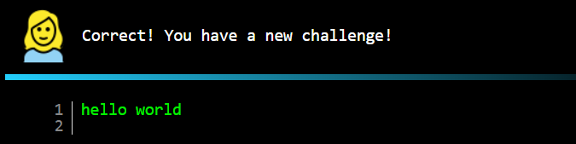 | 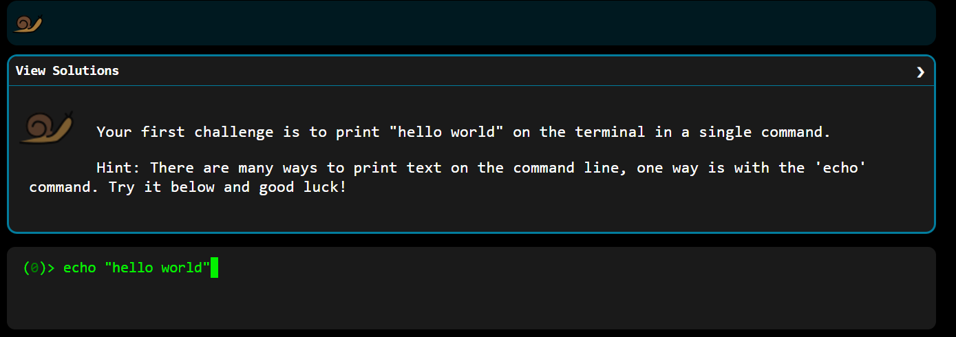

LEVEL 2 Show the current working directory | ✓ COMPLETED
Command / Technique: pwd
Purpose: Prints the full absolute path of the current working directory.
EVIDENCE
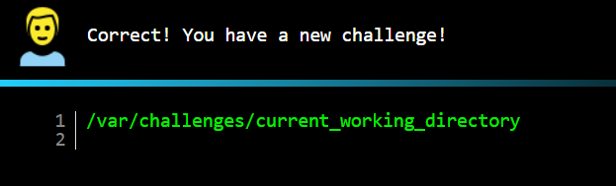 | 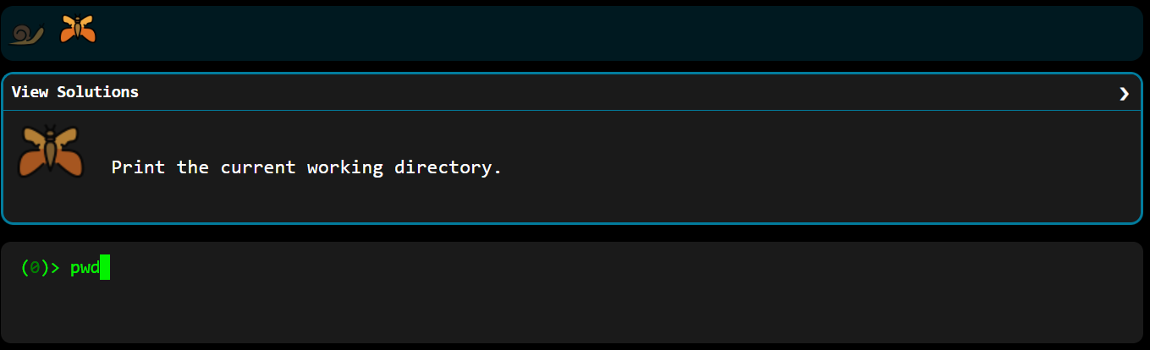

LEVEL 3 List directory contents, one per line | ✓ COMPLETED
Command / Technique: ls -1
Purpose: Lists files in the current directory with one entry per line.
EVIDENCE
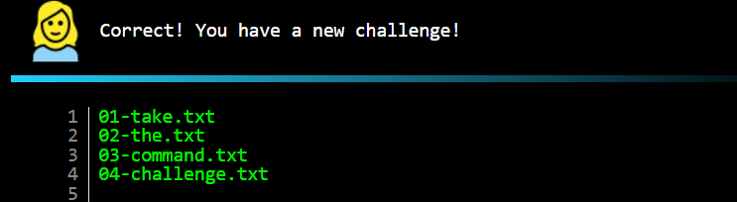 | 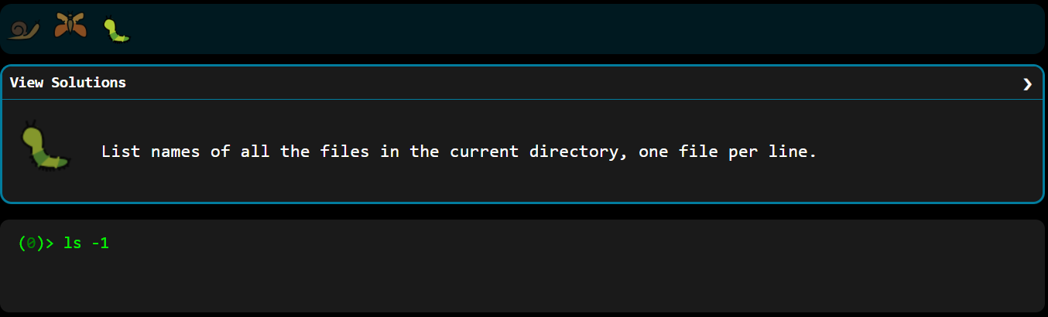

LEVEL 4 View the full contents of a file | ✓ COMPLETED
Command / Technique: cat access.log
Purpose: Displays the complete contents of a file in the terminal.
EVIDENCE
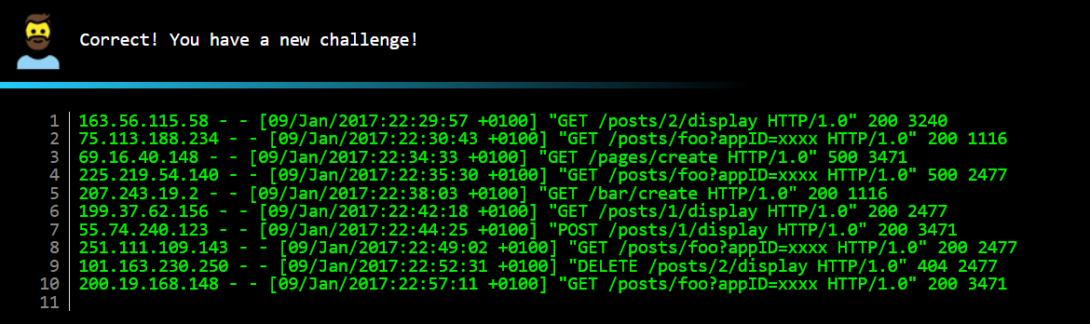 | 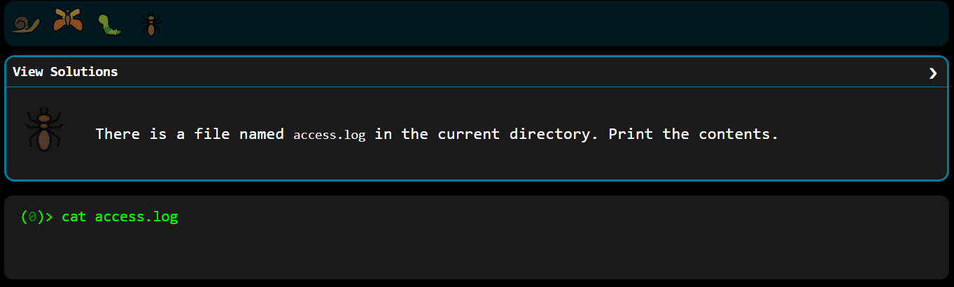

LEVEL 5 View the last lines of a file | ✓ COMPLETED
Command / Technique: tail -5 access.log
Purpose: Prints only the last 5 lines of a file — useful for recent log entries.
EVIDENCE
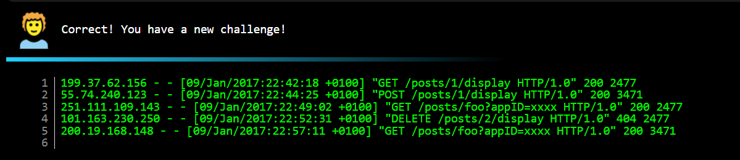 | 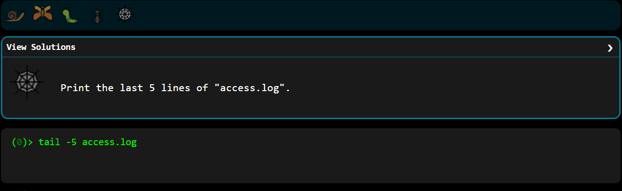

LEVEL 6 Create a new empty file | ✓ COMPLETED
Command / Technique: touch take-the-command-challenge
Purpose: Creates a new, empty file (or updates its timestamp if it exists).
EVIDENCE
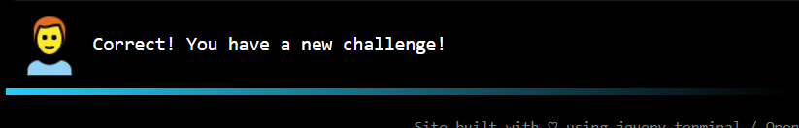 | 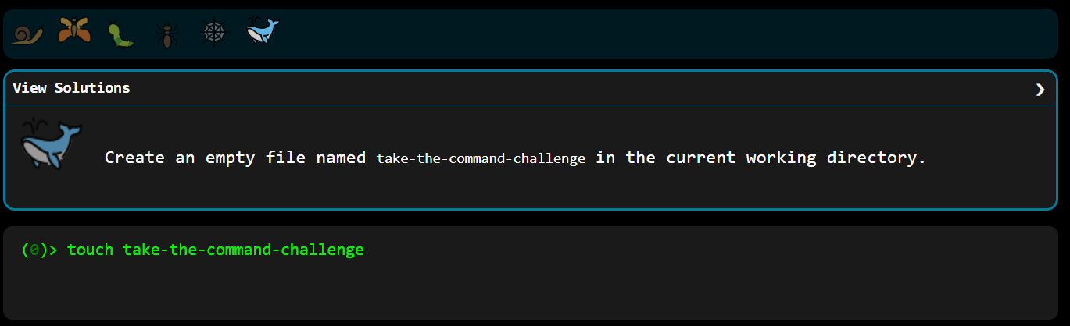

LEVEL 7 Create nested directories | ✓ COMPLETED
Command / Technique: mkdir -p tmp/files
Purpose: Creates a directory tree, including any missing parent directories (-p).
EVIDENCE
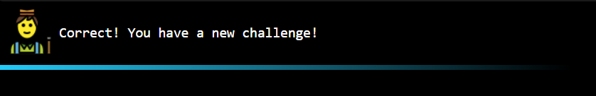 | 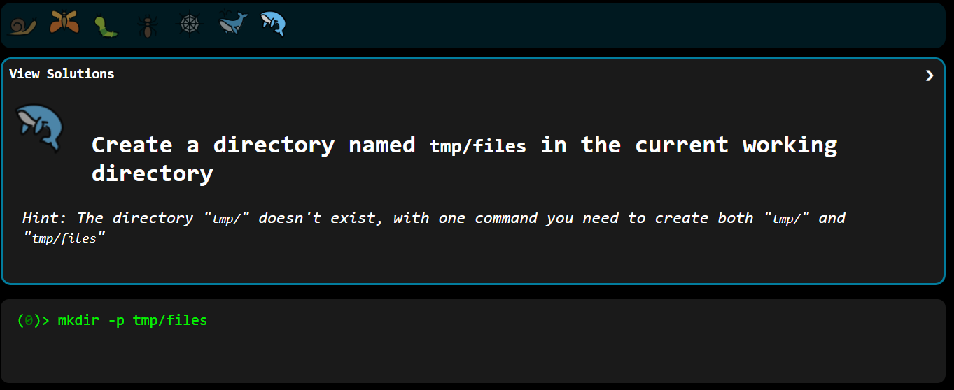

LEVEL 8 Copy a file into another directory | ✓ COMPLETED
Command / Technique: cp take-the-command-challenge tmp/files/
Purpose: Copies a file into a target directory; the original file is left untouched.
EVIDENCE
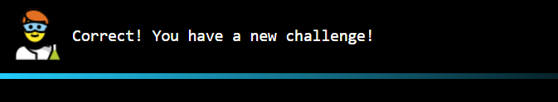 | 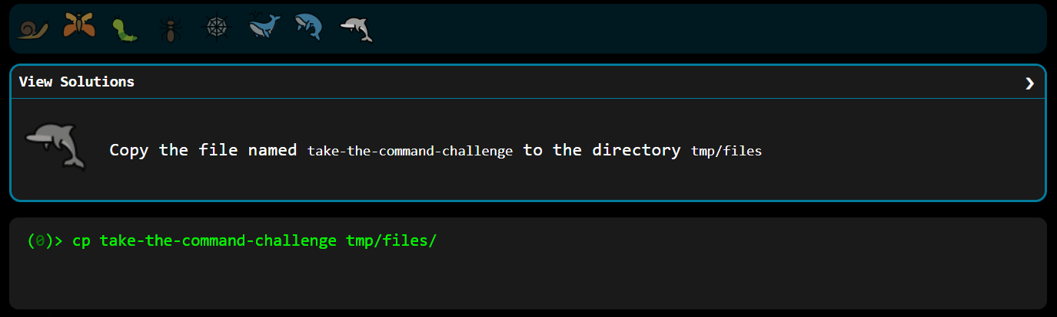

LEVEL 9 Move a file into another directory | ✓ COMPLETED
Command / Technique: mv take-the-command-challenge tmp/files/
Purpose: Moves a file into a target directory; the original location is removed.
EVIDENCE
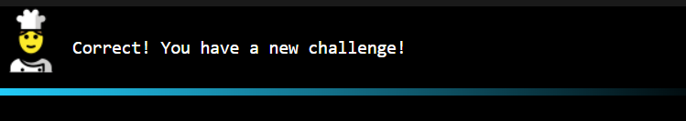 | 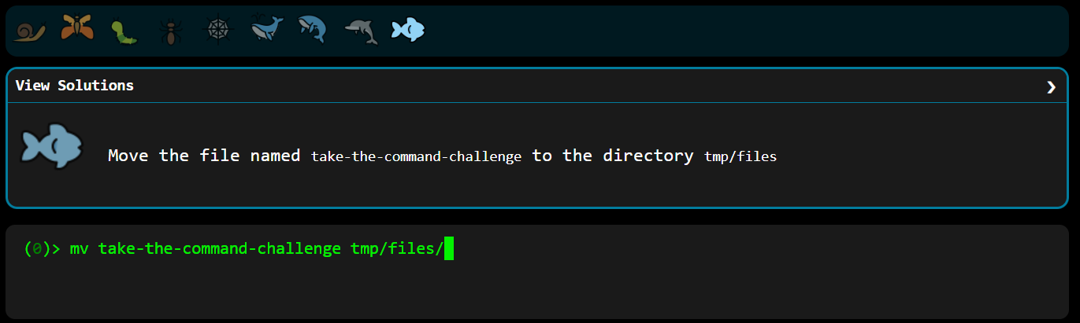

LEVEL 10 Create a symbolic link | ✓ COMPLETED
Command / Technique: ln -s tmp/files/take-the-command-challenge take-the-command-challenge
Purpose: Creates a symbolic link (shortcut) in the current directory pointing to the file’s real location.
EVIDENCE
 | 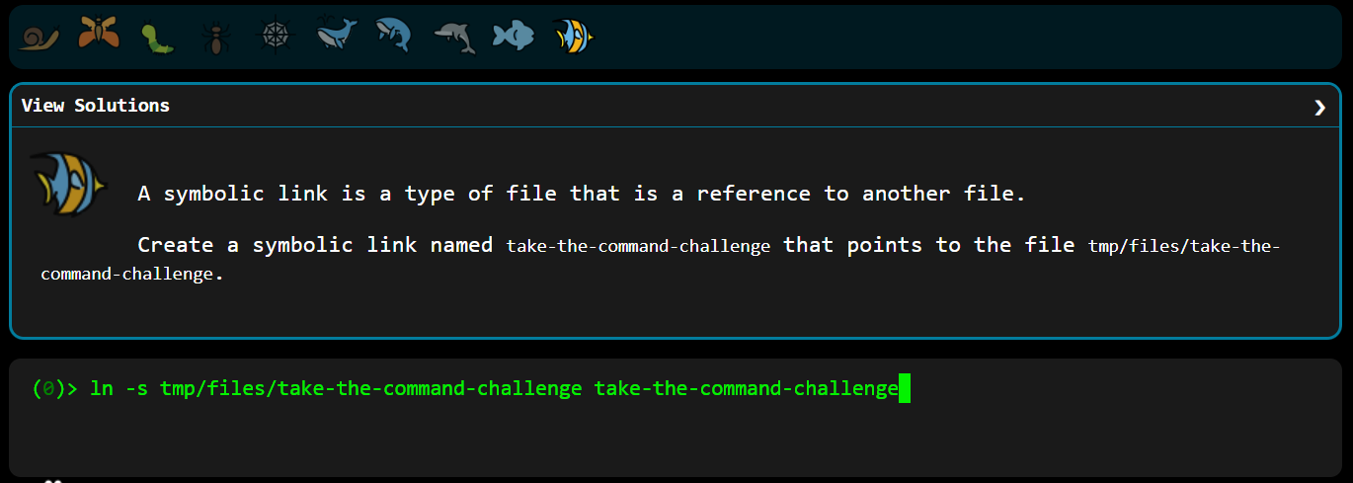

03 PART B — TRYHACKME
Guided room applying Part A commands to a realistic investigative scenario.
Room Name | Linux CLI — Shells & Bells
Completion Status | ✓ Completed
Room URL | tryhackme.com/room/linuxcli-aoc2025-o1fpqkvxti
IMPORTANT COMMANDS
ls / ls -a (list files, including hidden dot-files) · pwd (print working directory) · cd (change directory) · cat (read file contents) · grep (filter text and logs by pattern) · sudo su (switch to root) · exit (return to the normal user).
KEY CONCEPTS
Linux filesystem layout · hidden files (.name) · .sh shell scripts · log files under /var/log/ · root privileges and /etc/shadow · .bash_history as a forensic artefact.
PRACTICAL TASKS COMPLETED
Connected to the target machine and enumerated the user’s home directory; located a hidden guide file inside a subdirectory using ls -a; inspected a suspicious shell script left on the system; filtered system logs with grep to isolate failed login attempts; escalated to the root user with sudo su; and reviewed root’s bash history to identify the attacker’s actions.
EVIDENCE
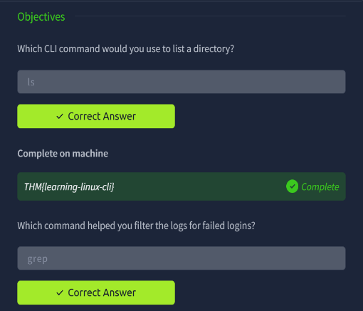 | 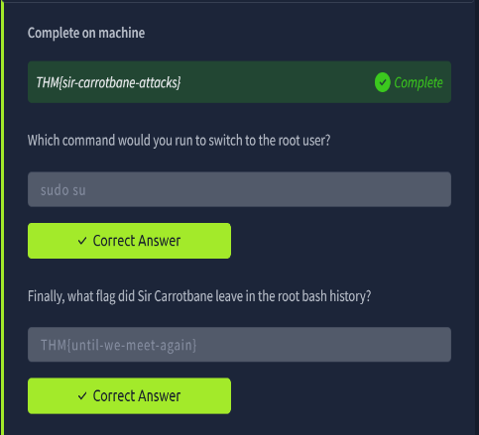 | 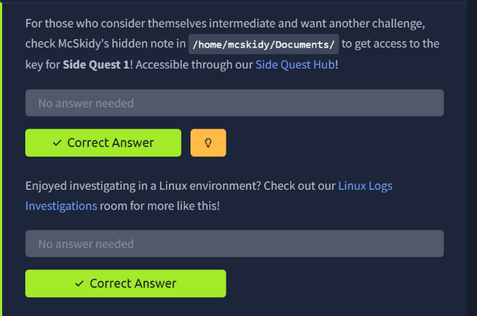
KEY LEARNING POINTS
- ls -a reveals hidden dot-files — attackers use them, so defenders must look for them.
- grep turns huge log files into targeted evidence; this is the basis of log analysis.
- Always read a .sh script’s contents — the filename alone tells you nothing.
- Root can access protected files such as /etc/shadow, which makes it the primary target.
- Bash history is a forensic artefact — it shows exactly what an intruder ran.

04 EVIDENCE STANDARDS
The following standards were applied when collecting and presenting evidence throughout this report:
☑ Screenshots are readable and clearly related to the task.
☑ Evidence shows actual completion rather than unrelated terminal output.
☑ Screenshots are placed beside or immediately after the relevant task.
☑ No evidence was fabricated, edited, or reused from another student.
☑ Unnecessary screenshots were avoided — only meaningful evidence is included.
☑ No complete walkthroughs or spoilers for the TryHackMe room are published.

05 LEARNING REFLECTION
Approximately 150–250 words on what was learned, new commands or concepts, the most difficult task, and how this practical work improved Linux and cybersecurity understanding.
The CMD Challenge built my file-system fundamentals. The commands I actually gained from were mkdir -p, which creates missing parent directories in one step, and the cp vs mv distinction — one duplicates, the other relocates. ln -s was the hardest: symbolic links were new, and the target-then-link argument order took several attempts to get right.
The TryHackMe room showed the same commands used for investigation rather than administration. ls -a exposed a file hidden by a leading dot. grep reduced a large auth log to just the failed logins. sudo su gave root access to files normal users cannot read.
The most useful lesson was that bash history is forensic evidence — it records exactly what an intruder ran, in order. Similarly, a .sh file’s contents matter far more than its name, since attackers and admins both use scripts.
My takeaway: these commands are trivial in isolation, but chained together they let you reconstruct an attacker’s activity on a compromised system.

06 FINAL SUBMISSION CHECKLIST
☑ 10 CMD Challenge levels completed.
☑ CMD Challenge evidence included.
☑ TryHackMe room completed.
☑ TryHackMe evidence included.
☑ Student information completed.
☑ Learning reflection completed.
☑ All screenshots are readable.
☑ Final document exported as one PDF.

